Simple Regression

The following dataset is a record of common different fish species in fish market sales. With this dataset, we will be trying to find if there is a relation between the weight of the fish and diagonal length and predict a model to estimate the weight of fish.

|  |  |  |
| --- | --- | --- |
| Species | Weight (in g) | Diagonal length (in cm) |
| Perch | 6 | 8 |
| Smelt | 7 | 9 |
| Parkki | 55 | 14 |
| Bream | 242 | 25 |
| Parkki | 300 | 26 |
| Roach | 390 | 31 |
| Pike | 500 | 32 |
| Whitefish | 1000 | 40 |
| Perch | 1100 | 44 |

**CORRELATION: -**

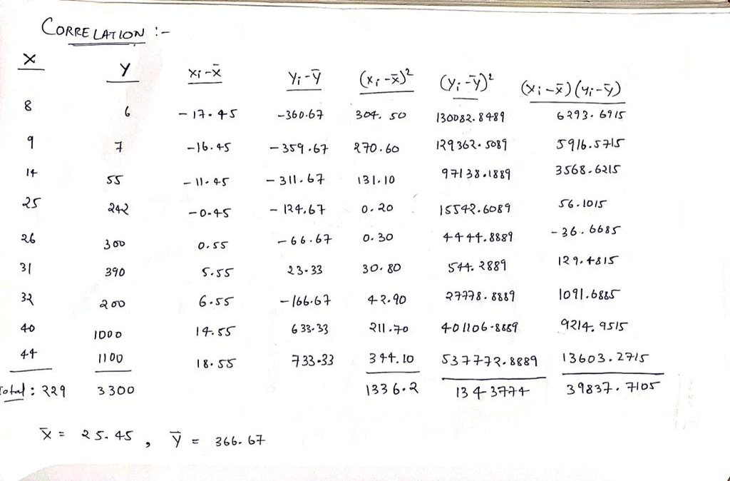

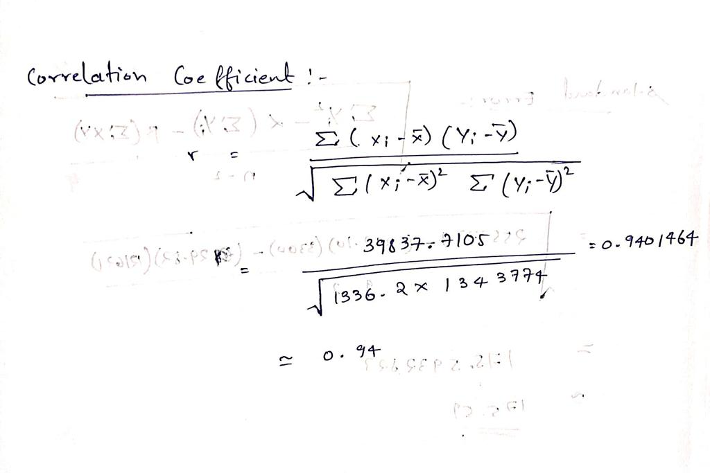

**DISCRIPTIVE STATISTICS: -**



**SCATTER PLOT: -**



**MODEL BUILDING: -**

Firstly, we will look at the correlation between the variables weight and diagonal length. Here we will be taking the weight of the fish to be Y a dependent variable and the diagonal length of the fish to be X an independent variable since in general as the the diagonal length of the fish increases the weight of the fish is supposed to increase.

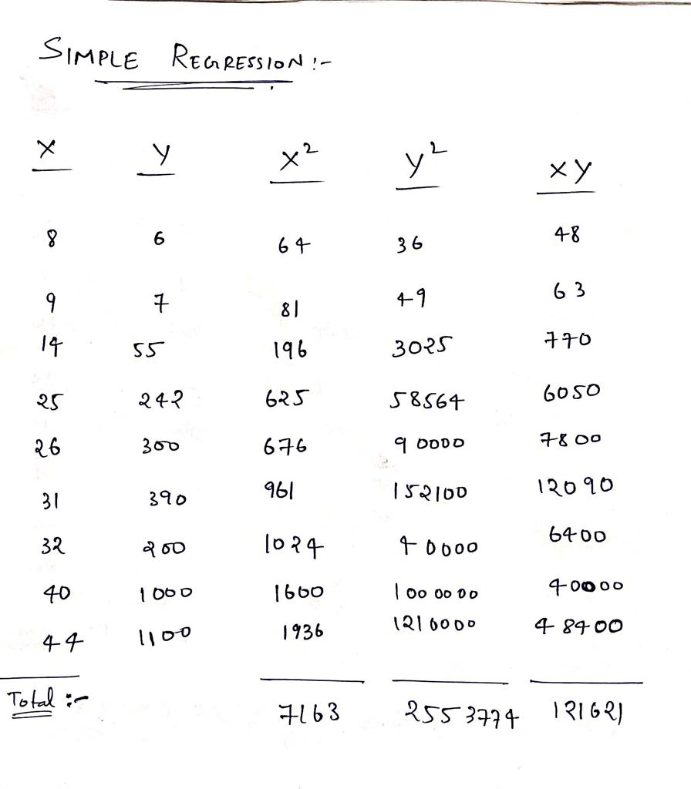

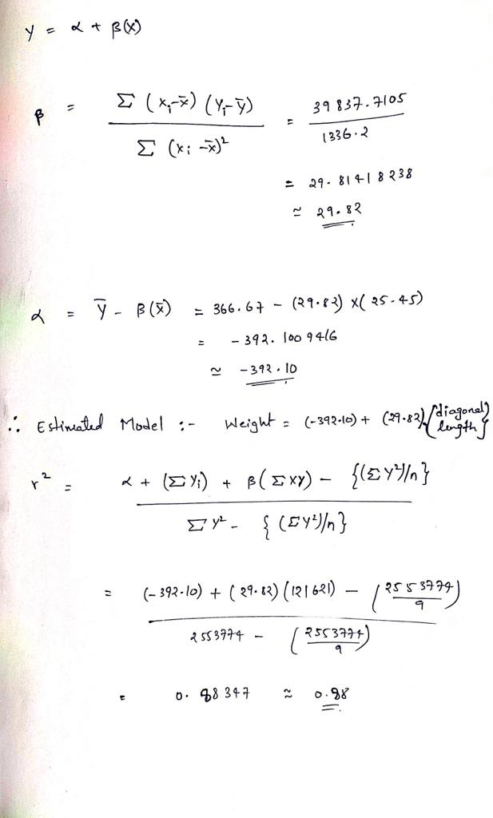

**STANDARD ERROR: -**

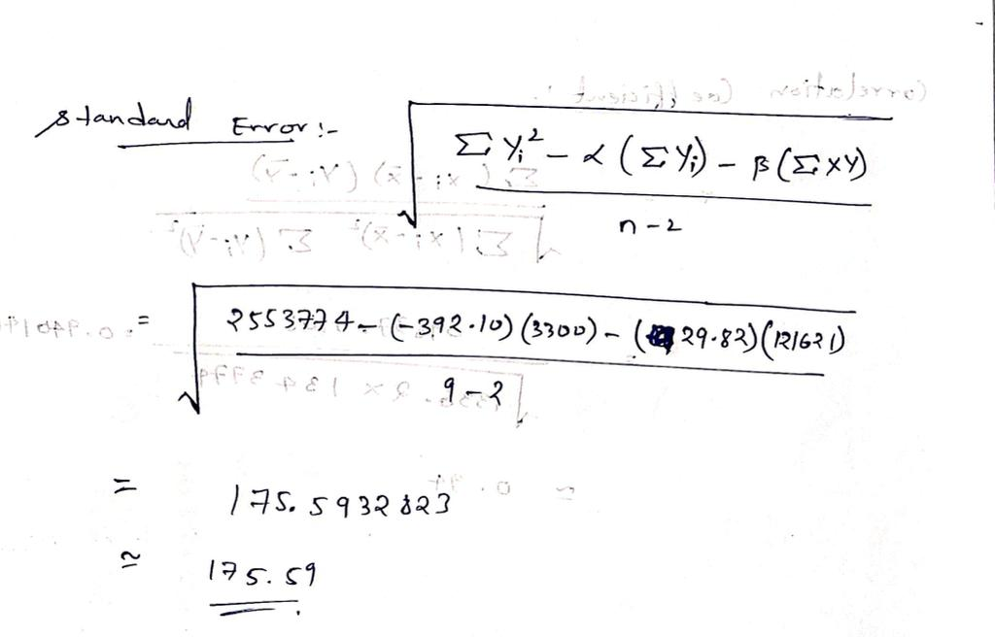

**CONCLUSION: -**

From the given data we get a correlation of 0.94 between the weight of fish and its diagonal length which is high degree of correlation (since the value is greater than 0.9). The R-squared value is 0.88 which means that our estimate model fits the 88 percent of the given data. But the standard error is large, giving us a conclusion that our estimated model is only a reasonably good one.

NAME: S.KRISHNAN

REG.NO: 200968068

ROLL.NO: 19

SEC: DSE-A